2018 NEW USA BASEBALL BAT STANDARDS!

The change in bat standards is to make youth bats perform more like wooden bats. Starting January 1, 2018, Little League Baseball bats will need to have the USA Baseball “USABat” stamp/logo on it (please see below regarding Tee-ball bats). For baseball bats 27 inches in length, or longer, the barrel options will be 2-¼ inches and 2-⅝ inches. Most of the SHLL Majors and Minors teams will be moving to the 2-⅝ inch barrel; however, a player can still use a USA Baseball approved 2-¼ inch bat. For overall player bat sizing (length & weight of bat), please see sizing information below.

ANY BAT, 27 INCHES IN LENGTH OR LONGER, THAT WAS USED BEFORE JANUARY 1, 2018 THAT DOES NOT HAVE THE USA BASEBALL LOGO ON IT CANNOT BE USED IN LITTLE LEAGUE BASEBALL. PLEASE CHECK YOUR CHILD’S BAT. YOU MAY NEED TO PURCHASE A NEW STANDARD BAT.

IF YOU PURCHASE A BAT AND YOU ARE UNSURE OF THE BAT FOR ANY REASON, DO NOT REMOVE THE WRAPPER THAT IS ON THE BARREL OF THE BAT! YOU WILL NOT BE ABLE TO RETURN OR EXCHANGE THE BAT!

The USA Baseball logo is usually located just above the grip or tape of the bat handle and also on the retail wrapper on the barrel of the bat. These are examples of what the USA Baseball logos look like:

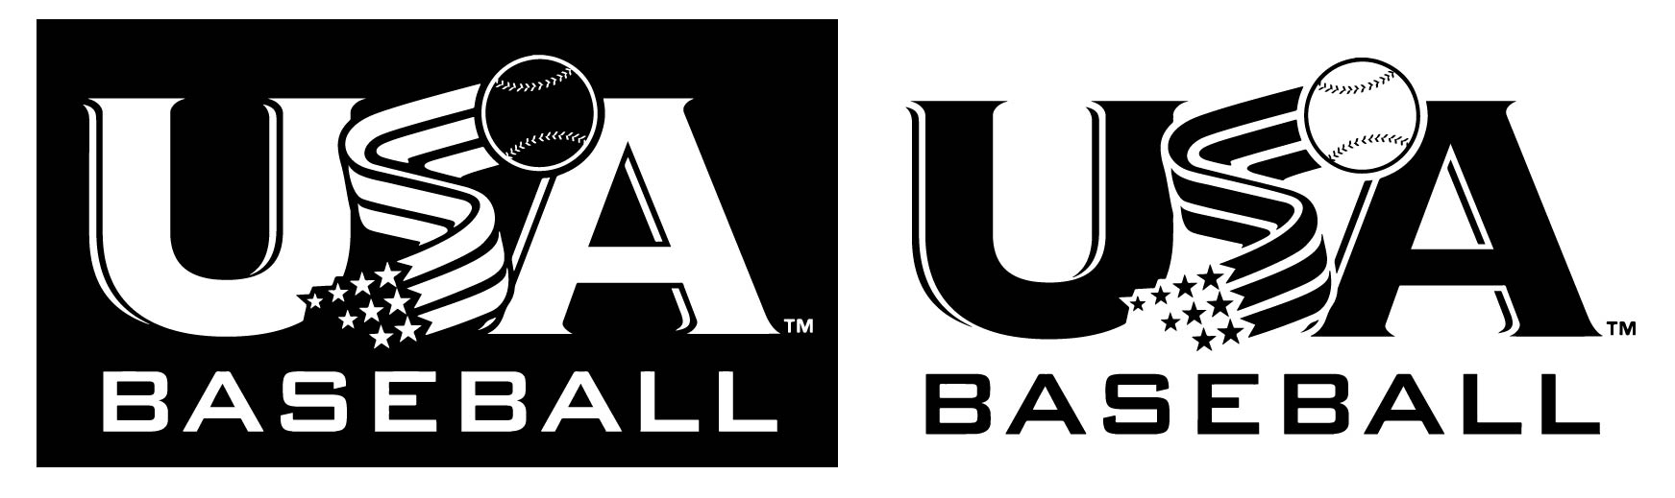

TEE BALL BATS
A Tee-ball bat is a bat 26 inches in length or less (see below for bat sizing). Tee ball bats are not required to undergo lab testing to receive approval under the USABat program. However, to be approved for play, Tee-ball bats must carry the USA Baseball logo accompanied by the following text: “Only For Use With Approved Tee Ball Bats”. Tee-ball bats used before January 1, 2018 can still be used; however, these bats will need a USABat sticker placed on the Tee-ball bat. Tee ball bats manufactured after the new rule will already include the USABat Baseball mark, and will not need additional markings. For bats needing the sticker, this is how the sticker looks

:

FREQUENTLY ASKED QUESTIONS
CAN I STILL USE MY CURRENT BAT?
You must use a bat with a USABat compliance logo after January 1, 2018. Bats regulated by the new USABat standard are now available.
WHY THE NEW BAT STANDARD CHANGES?
The new USABat standard will create wood-like performance in youth baseball bats in order to make the game more uniform at the youth level and ensure the long-term integrity of the game. Similar to the BBCOR standard implemented in 2011. USA Bat regulates how much trampoline effect the barrel of a bat has on a ball. Unlike the -3 length-to-weight ratio restriction for BBCOR bats, USABat will not have a drop weight limit. Players within the affected organizations will also now be able to use a 2 1/4” or 2 5/8” barrel bat as long as it carries the USABat compliance mark.
WHAT SHOULD I EXPECT FROM A NEW STANDARD BAT?
New youth baseball bats under this standard will have less trampoline effect and consequently less ball exit speed. Balls fisted or in off the hands are much less likely to carry over the infield for hits. It will be more difficult to hit the ball far and with high velocity, but far from impossible.

Sources: www.usabaseball.com; www.baseballsavings.com; www.dickssportinggoods.com

How to Measure Children for a Tee-ball Bat (26 inches and below)

Tee-ball bats are usually around 26 inches in length or less. If you’re shopping for a Tee-ball bat for your child, the process of measuring will be a little different. If your young player is between 3’ and 3’4”, start with a 26-inch bat and increase the bat size 1 inch for every 4-to-5 inches that they grow. The following steps are the ideal process for determining the correct bat size for children:
- Measure his/her height - Measure with his/her baseball cleats on.
- Compare him/her to the bat - Stand a bat up next to your child. The bat should reach, but not exceed, your child’s hip. If it reaches past his/her hip area, it’s going to be too long to swing.
- Weigh them - weight is a contributing factor to which bat he/she should swing because the little league bat size chart uses a combination of weight and height to determine the best bat choice
  - In general, children under 60 pounds should swing a bat between 26 and 29 inches long.
  - If your child weighs more than 70 pounds, his/her bat should range from 28 to 32 inches in length.
Choosing the Correct Size Baseball Bat for your Child (27 inches & above)
When it comes to choosing the size of your bat, there are different ways to measure for it. The best way is to choose what you feel comfortable swinging. A general rule to follow is to never go up more than an inch at a time. This makes it easier to adjust for the new bat without drastically changing your swing. Don’t worry, if you are new to the game or want to re-size yourself, there is a way to estimate what size you should be using.
BAT LENGTH
When selecting the proper bat length, a good rule of thumb for any age group is to place the handle end of your bat in the middle of your chest and extend it out toward your index finger with your arm extended to your side. If the bat goes far beyond your index finger, it’s probably too long. If it is around your palm or wrist, the bat is too small. You can also use the Age & Height Diagram as well. See diagrams A, B, and C.
BAT WEIGHT
The right weight is very much how you feel. If you take multiple swings and the bat feels heavy or begins to drop, the bat is probably too heavy. Try holding the bat handle and extending your arm to your side. If you can’t hold the bat extended for approximately 30 seconds, the bat might be too heavy for you. You can also use the Age & Height Diagram as well (diagram B) to find your child’s appropriate bat weight.
Check the drop of the bat, too. Drop refers to the length of the bat minus the weight of the bat. The higher the drop, usually the lighter the bat is. Again, some leagues and/or programs have a limit on how much the drop can be so always check your rule book. If you’re a power hitter, you may do well with a slightly heavier bat. If you play small ball and try to get base hits, a smaller bat will give you more control. For more information on baseball bats, see diagram C.
Diagram A:
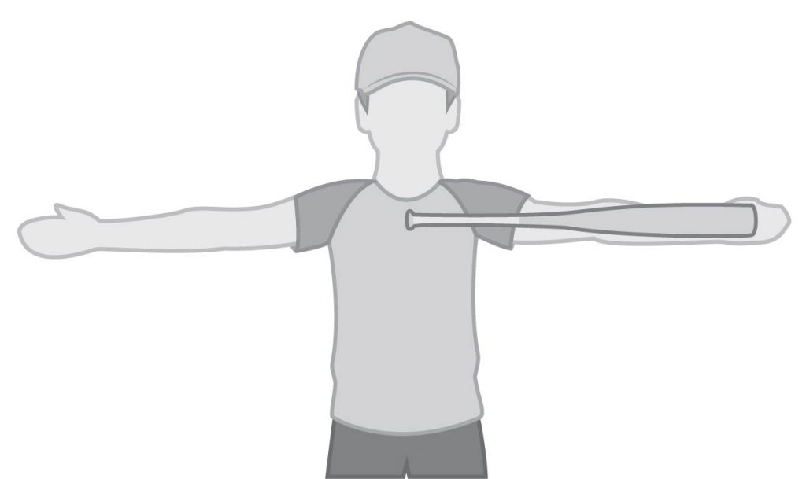

Diagram B:
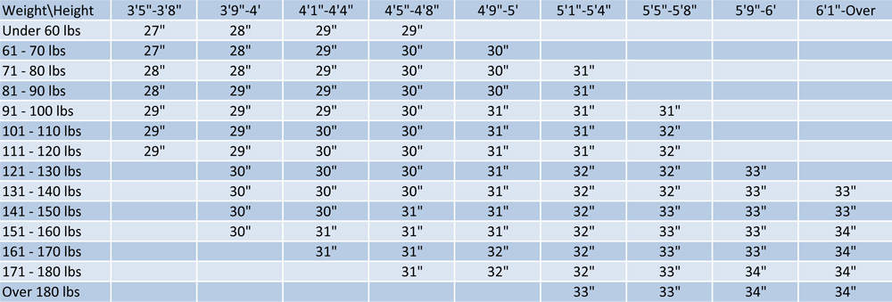

Diagram C:
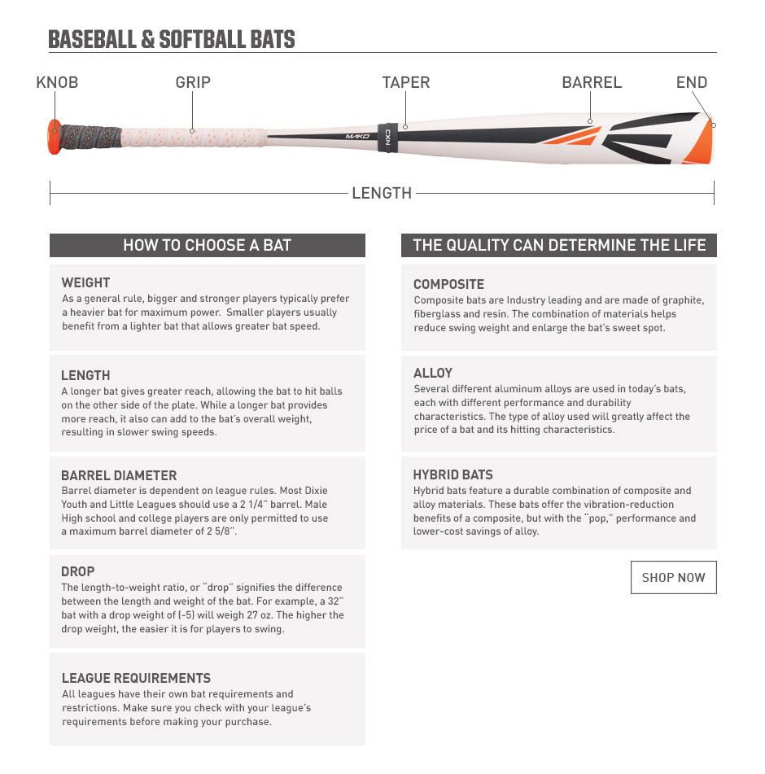
www.baseballsavings.com

More Tips on Choosing the Correct Baseball Bat
Before looking at weights, it is important to understand the terminology of bat weights first. A bat weight is measured by the minus or drop weight. Drop weight is the difference between the length of the bat and the weight of the bat. So a bat that is 30 inches and has a drop weight of (-10) will weigh 20 ounces. The bigger the drop weight is, the lighter the bat will weigh. The only league that regulates bat weight is High School and College bats, which have to be a (-3).
When choosing the weight of your bat it is important to remember that neither the heaviest nor the lightest bat is the best to go with. It is best to find the best balance between the two. After finding a baseline for the length of the bat, it is important to incorporate the length of the bat into deciding on the weight. If you choose a longer bat, it might be better to go with a lighter bat. But if you choose to go with the perfect fit for the bat, it might be a good option to go up an ounce in weight.
The reason that it is important to choose the right balance between length and weight is because it makes a difference in the physics of the swing. For instance, if you have a long, light bat, you can swing it very fast, but it will not have much inertia behind it. If you swing a short heavy bat, you will not have the fastest bat speed but will have plenty of inertia. The choice of which length and weight is a personal choice of what you are comfortable with. The charts below will help give you a ballpark idea of what size and weight you should be using.

